Project Identification Form (PIF)
Project Type: Full Size Project
the GEF Trust Fund


Submission Date: 14 August 2009
Re-Submission Date: 25 September 2009
Indicative Calendar*
Milestones | Expected Dates  mm/dd/yyyy
Work Program (for FSP) | Nov. 2009
CEO Endorsement/Approval | Oct. 2010
Agency Approval Date | Dec. 2010
Implementation Start | Jan. 2011
Mid-term Evaluation (if planned) | June 2013
Project Closing Date | Dec. 2014
* See guidelines for definition of milestones.
part i: project IDentification
GEF Project ID: 4055 Project duration: 48 months
gef agency Project ID: 4315
Country(ies): Senegal
Project Title: Technology Transfer: Typha-based Thermal Insulation Material Production in Senegal
GEF Agency(ies):
Other Executing partner(s): Direction de l’Environnement et des Etablissements Classés (DEEC), Direction Nationale de l’Industrie, Direction Nationale de l’Energie, Agence Nationale de la Recherche Scientifique Appliquée (ARESA), SOCOCIM Industries (Groupe Vicat, Senegal), Ciments du Sahel (Senegal),
Naporo Klima Dämmstoff GmbH (Austria),
Ort_GangArchitektur (Austria), International Organization for Migration (IOM).
GEF Focal Area (s): Climate Change
GEF-4 Strategic program(s): Strategic Program on Technology Transfer
Name of parent program/umbrella Project (if applicable): N/A
- Project framework
Project Objective: Facilitation of the transfer of the technology for producing an innovative thermal insulation material using bulrush (typha australis).
Project Components | Indicate whether Invest. TA, or STA^{b} | Expected Outcomes | Expected Outputs | Indicative GEF Financing |  | Indicative Co-Financing |  | Total ($)  c =a + b
 |  |  |  | ($) a | % | ($) b | % | Total ($)  c =a + b
1. Preliminary Inputs | TA | Preparatory works on the typha project in Senegal | Project concept is launched, competent local and international stakeholders are approached and organized in a coherent project team. | 0 | 0 | 100,000 | 100 | 100,000
2. Basic Evaluation & Research | TA | Ascertainment of reliable data and facts about typha, assessment of energy and technical standards | Comprehensive R&D literature review is performed on:  - Typha data (biology, biodiversity, water management, cartography);  - Energy consumption in building (consumption analysis, energy flux, energetic building analysis);  - Specific technical data (climate data, analysis of national building codes and industry standards). | 200,000 | 67 | 100,000 | 33 | 300,000
3. Transfer of Thermal Insulation Material Production Technologies and Know-How | Ta  &  Inv. | The process for producing typha-based insulation material scientifically and commercially certified and patented | The production chain and manufacturing process are validated, in particular:  - cutting, harvesting techniques, drying process and logistics;  - milling and particle design;  - cement typha assembly test series;  - wall design;  - insulation material production technology process is adapted to the local conditions. | 300,000 | 50 | 300,000 | 50 | 600,000
4. Establishing Local Production | Inv. | Investment in production facility of the innovative insulation material | A production line is set:  - defined steps for up-scaling the production of thermal insulation material;  - engineering;  - machine production;  - production facilities;  - test production;  - regular production. | 700,000 | 28 | 1.800,000 | 72 | 2.500,000
5. Adapting innovative material to building technology | TA  &  Inv. | Transfer Technology & tailor technical specifications for the use of the thermal insulation material in buildings | Technical solutions are tested and validated to fix new insulation material to building shell, solving in particular:  - coating and salt protection;  - fixing systems;  - compatibility with climatic conditions, ventilation, air handling, mould resistance. | 250,000 | 50 | 250,000 | 50 | 500,000
6. Demonstration project | TA  &  Inv | Public or government building rehabilitation with typha insulation as energy saving model structure | - A government building is fully retrofitted with innovative thermal insulation;  - The thermal performances (level of comfort and energy consumption) are monitored and analyzed over a year-long period. | 200,000 | 33 | 400,000 | 67 | 600,000
7. Dissemination of typha building technologies | TA | Thermal insulation becomes common practice in all new construction | - Building stakeholders, architects, building experts are trained first in Senegal’s largest cities, then in the rest of the country;  - Innovative material and know-how are widely disseminated;  - Senegal thermal building codes are implemented faster than initially planned | 150,000 | 50 | 250,000 | 50 | 460,000
8. Monitoring and Project Management |  |  |  | 200,000 | 50 | 200,000 | 50 | 400,000
Total project costs |  |  |  | 2,000,000 |  | 3,400,000 |  | 5,400,000
ªList the $ by project components. The percentage is the share of GEF and Co-financing respectively of the total amount for the component.
^{b} TA = Technical Assistance; STA = Scientific & Technical Analysis.
- Indicative co-financing for the project by source and by NAME (in parenthesis) if available, ($)
Sources of Co-financing | Type of Co-financing | Project
Project Government Contribution (ARESA and Direction de l’Industrie du Sénégal) | Cash | 500,000
GEF Agency(ies) UNDP Senegal | Grant
Bilateral Aid Agency(ies) |  | 0,000
Multilateral Agency(ies):  European Commission (i.e. Energy Facility) | Cash | 800,000
International Organization for Migration | Cash | 200,000
Private Sector: Sococim industries (to be confirmed) | Cash/In-kind | 1.600,000
Ortgang & Naporo | In-Kind | 100,000
Others |  | 200,000
Total Co-financing |  | 3,400,000
- Indicative Financing Plan Summary For The Project ($)
 | Previous Project Preparation Amount(a) | Project (b) | Total  c = a + b | Agency Fee
GEF financing |  | 2,000,000 | 2,000,000 | 200,000
Co-financing |  | 3,400,000 | 3,400,000
Total |  | 5,400,000 | 5,400,000 | 200,000
- GEF Resources Requested by agency (ies), Focal Area(s) and country(ies)1
GEF Agency | Focal Area | Country Name/  Global | (in $)
GEF Agency | Focal Area | Country Name/  Global | Project (a) | Agency Fee (b)² | Total c=a+b
Total GEF Resources
¹ No need to provide information for this table if it is a single focal area, single country and single GEF Agency project.
² Relates to the project and any previous project preparation funding that have been provided and for which no Agency fee has been requested from Trustee.

part ii: project JustiFication
- State the issue, how the project seeks to address it, and the expected global environmental benefits to be delivered:
The project consists in using invasive vegetal specie found in the Senegal River (namely bulrush or typha australis).
This wild plant exuberantly grows and causes serious problems for Senegal’s ecosystem and economy. Various government initiatives have been developed to address this plague without success so far. The Austrian company NAPORO has developed insulation panels out of typha and is the only company to use this raw material worldwide. Instead of fighting against an esteemed weed, typha can be harvested and become a valuable raw material.
Furthermore, the insulation performance of the typha plant could solve a second major problem of the country: shortage of electric power and inadequate insulation of the buildings. The absence of thermal insulation in any construction in Senegal forces the use of air conditioning to maintain a minimum level of comfort. Air conditionings consume up to 60% of buildings’ electric consumption. By using typha based insulation materials in Senegalese buildings the energy consumption could be lowered considerably.
The Typha Construction Material Project is an interdisciplinary project with positive effects on energy efficiency, climate change and biodiversity. The basic idea is to produce construction materials on the basis of the invasive weed typha australis which covers a big part of the delta area of the Senegal River.
The combination of typha and cement offers a wide range of promising construction products, ranging from additive and formwork to strong panels, columns and beams. Typha panels can be integrated in building shell and contribute to the overall thermal insulation of the building. The concept of using typha as an insulation material has already been validated in some European based research institutions. The project consists in refining the technology in order to transfer it to Senegal. In particular the project will test, tailor and validate all technical dimensions to Senegal industrial and construction context. This project will allow Senegal to benefit from a locally produced thermal insulation material. So far, energy efficiency in the building sector has been limited by the lack of available thermal insulation material in the country.
Senegal River is a 1,800 km long lifeline in the Sahel shared by four countries: Guinea, Mali, Mauritania, and Senegal. Since the last five decades, the river has been seen as a means of strengthening the national economies of its member states. The Senegal River development schemes in their modern form date back to early 1970s when the Organization for the Development of the Senegal River (OMVS) issued its management plan which included three interrelated components: irrigation, navigation, and energy.
As a response to the third component of the OMVS management plan, a hydro power dam in Mali (Manantali dam) and a salt-wedge dam in Senegal (Diama dam) were built in the early 1980s. However, these dams have proved controversial partly because of its environmental and health-related impacts.
Indeed, these dam projects interfered with the ecosystem and caused the proliferation of individual species, especially bulrush, also known as typha australis, an invasive river plant. This plant quickly proliferated in the Senegal River and today typha has invaded an estimated area of 140,000 hectares and spreads at an uncontrolled speed (circa 10% per year). It grows with serious consequences on livelihood and health of the local population (such as bilharziosis and malaria).
In parallel, the region lacks important raw materials, especially renewable ones. Cement comes from domestic production and is omnipresent on the local market, but nowadays it still lacks suitable aggregates and complementary materials. As a consequence, cement often provides sub-optimal standards concerning comfort and thermal insulation.
Because of the political independency and swift opening to the world/global economy most constructions adopt common international styles, i.e. concrete skeleton structures, largely glazed, no specific constructional heat protection, fully equipped with electric air-conditioning.
Today, there is a need in Senegal for effective, thermally efficient and affordable building material. Senegal is currently facing severely dampened industrial and economic development due to power production shortfalls and the poor quality of electricity supply. For several years now, the Government has tried to eliminate power shortages, with no success so far. As a result of financial over-commitment, volatile fuel prices, and outdated installations, the whole of Senegal’s energy sector has found itself in distress. Additionally, power shortages seem to have led many small and medium enterprises to bankruptcy. Larger companies and administration have been relying on diesel generators and have also reported serious declines in output.
The National Power Utility Company, SENELEC, like numerous power companies in Africa, is facing difficulties to keep up with electricity demand. Its effective power demand peak is currently around 350 MW (relative to an installed capacity of 459 MW in 2006) and expected to reach 600 MW by 2012 and to exceed 1,000 MW by 2020. Electricity demand is mainly driven by a dynamic construction sector. Air conditioning is being generalized while buildings are designed without thermal considerations. Thermal building codes have been formulated but are not formally adopted and practically implemented yet.
Therefore, there is a tremendous need to supply proper thermal insulation materials to the building sector.
As a response to this harsh situation, technologies for producing plant-based thermal insulation materials are advanced, especially in Europe and in emerging countries such as China or Brazil. They range from simple technologies, such as straw ball techniques, to advanced composite materials based on cement. In Senegal, there is vivid construction activity and local and international producers of building materials are already well implanted, especially cement producers. These actors are interested in new technologies, as these are related to the national upgrade program in local industries and to the specific component aiming at engaging industries on the path of increased energy efficiency.
A promising solution to this set of issues is the use of typha-based thermal insulation material for the building sector. The project consists in transferring technology mainly from Europe and Brazil to local partners in order to develop an agro-industrial process to produce insulation material for the construction sector, using some abundant, but useless resources, in order to meet the newly formulated energy efficiency standards in Senegal.
The project is designed to remove some of the most significant barriers to the transfer of the typha-based thermal insulation manufacturing technology in the construction sector and allow a large-scale production of typha-based thermal insulation material as an energy-efficient and locally-produced solution to both the domestic and export markets.
The project includes seven (7) technical components:

Component 1 &2 — Preliminary Inputs and Basic Evaluation and Research

The preparatory work consists of the following:
- Qualitative specification of typha australis; comparison with other plants or biomass raw materials which are used as/in construction materials (such as wood fibers, bamboo, reed, straw, etc.);
- Investigation of local building techniques; identifying existing local materials (cement); pinpointing additional needs and technical problems in existing building techniques; description of social acceptance concerning the issue;
- Selection and involvement of a group of local and European experts in Architecture, Building Materials, Typha Technology, Hydrobotanic and Ecology (Arch. Mbacke Niang; Inst. of Building Materials, Technical University Vienna; NAPORO; Institute of Ecology, University Anta Diop, Dakar; Prof. Janauer, Inst. of Hydrobiology, University of Vienna);
- Information of all involved Senegalese Agencies and Ministries, the cement and fiber cement industry, representatives of architecture and the building stakeholders as well as the development banks and the national housing bank in the frame of a Typha Building Material conference;
- Definition of an international cooperation project; contacting of potential partners.

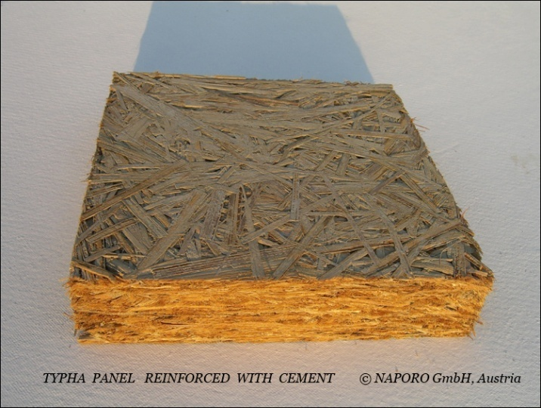

Figure 1: Picture of a Typha insulation panel, reinforced with cement

Component 3 — Transfer of Thermal Insulation Material Production Technologies and Know-How
After 3 years of scientific research, in cooperation with such renowned institutions as the Fraunhofer Institute and the National Research Institute FFG, Naporo has developed several products based on typha. Some of them, as the insulation panels, are patented and already engineered for a large scale production.

The technical process for the production of the typha panel has to be adapted to the Senegalese conditions. The different climate, the availability of building products and the quality of the raw materials like cement and typha force the producers to change the product design. Also different market situations make it necessary to develop a special Senegalese product. Other aspects are different logistics in the country and a not comparable structure between labor and material costs.

Harvesting and mowing the typha is also completely different than in Europe due to the different water situation. Mowing boats have to be constructed with high capacity, yet movable, as well as new cutting tools. Following the current international tendency to favor local renewable resources over petrol-based materials thypha-fibers and the local cement are worked up for in innovative insulation material using existing plant fibers composites as basic examples (wood fibers composites and others). The insulation capacity is regulated by the mass.

Besides of the aimed insulation material (low mass) other promising Typha-Cement-products of a higher mass are possible, e.g. fiber-concrete columns and beams which could have a bearing function into the building. Because of the local lack of wood they would have an important role, too. Even if this aspect will be a different project, the basis for this innovative technology is done within the framework of the actual one.

The developed and optimized product will be tested thoroughly in the laboratory and under the rough conditions of practical constructing. Before production capacities will be established, the typha climate wall must undergo a complete series of practical applications.

The developed production and application technology will be patented. The production partner in Senegal will get a license for the typha insulation panel.

Component 4 — Establishing Local Production

The production technology for the typha insulation panel is based on the following steps:
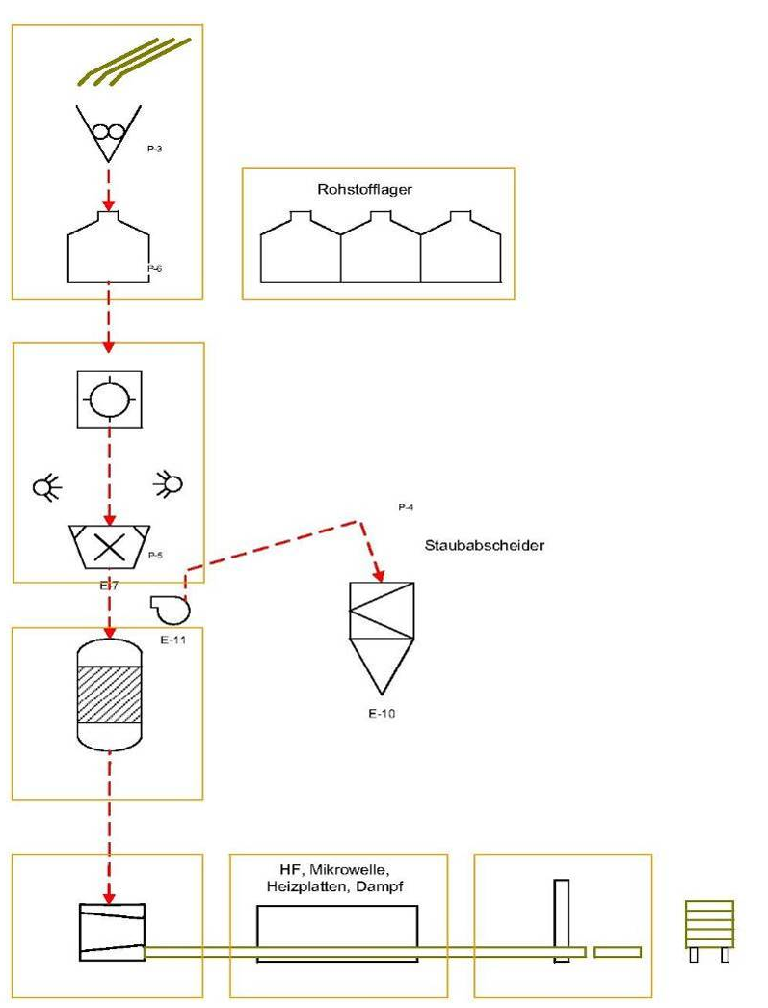
Cutting | Under water cutting/cutting boats
Drying | Convection drying process
Milling | Low energy cutting process:  guillotine cutter,  self-controlling rotation cutting machine
Mixing | High pressure moistening of the typha particles, low abrasion processing,  optimized water/cement ratio
Pressing and drying | Low-energy drying process with retarded water delivery for optimized tensile strength

This component aims at defining the successive steps for building up a production line for the thermal insulation material in cooperation with the identified industrial partners (as SOCOCIM Industries and Ciments du Sahel). Different from the European situation, the production process could be automated only in parts. The process therefore has to be adapted to the local conditions. This gives the opportunity not only to use local raw materials. Local population will be associated to the typha harvesting and production process.

Prior to downstream industrial activities, the project will:
- Assess the social and environmental impacts all along the proposed industrial process, considering natural, social and economic aspects;
- Define a strategy to help local population — especially young women and men — to gain a practical experience in the upstream innovative harvesting and agro-processing techniques.

The first step after the laboratory tests is the test production on a pilot plant station. This “intermediate scale tests” cannot be done in Senegal. We will therefore use existing facilities in Europe. With the experiences from these tests, the engineering for the production line in Senegal can be done. The worked out machine layout is the basis for an investment plan and the production of the machines. Parallel with the engineering of the machines facilities have to be build up. Also the recruiting of staff members and their education can be done.

After these steps, the production of a first pre-series can be started. The material from this first test production is used for component 6 (demonstration project). With the practical experiences the production line can be optimized and the regular production can be started.

Component 5 — Building technology
This component aims to integrate the developed insulation element into the entire system of building, looking for the most effective positions concerning thermal insulation due to the specific climatic conditions. We develop the most cost-efficient working methods concerning fixing, covering and fitting to third elements. Possible negative effects are defined, calculated and eliminated. Complementary strategies of bioclimatic buildings are applied in order to maximize the positive effect of insulation. Existing know-how is used and specified in cooperation of international experts and local planners and production engineers.

Due to the specific climatic and atmospheric conditions conventional multi-layered wall layouts are assessed in the calculation model and in 1:1 experiments, especially regarding the sequence of layers. The insulation material is tested under variable conditions of temperature, humidity and different building techniques in the four different climatic zones of Senegal. Negative effects such as undesirable condensation are defined, calculated and eliminated.
Based on these results, different fixing technologies and cover systems for the insulation material are worked out and compared. The western technologies are linked with the local techniques. Systems for new houses and renovation of existing buildings are developed and optimized in laboratory tests.

Moreover, the produced material will be tested considering the common standards in green building. Based on the results of the previous activities, the various typha-based end-products will be certified and precise specifications for their production and use in bioclimatic buildings will be formulated in close partnership with professional organizations involved in the construction sector in Senegal (typically the National Association of Architects).

Component 6 -- Demonstration project

In order to show the usability of the research activities, a demonstration building will be insulated with the typha-climate-wall. This show case construction will be done on a governmental/public building. The demonstration will be designed to become a national reference, a “landmark project”. In addition to the typha climate wall concept, shading and ventilation techniques will also be a part of this demonstration project. The energy data of this building will be recorded before and after the rebuilding to deliver convincing figures and statistics to everybody. A long-term monitoring will be included.

Component 7 -- Dissemination of typha building technologies
This component aims to explore the domestic and international market and to refine efficient financial or fiscal incentives for an accelerated diffusion of the innovative typha-based thermal insulation material in existing buildings. Furthermore, it aims to pave the way for its spread by capacity building/development for local planners, building stakeholders and workmen. Finally, it aims to eliminate start-up difficulties through the initiation and technical support of at least one housing project done by a representative developer. The project intends to stimulate the demand for the typha-based insulation material through the exploration of market opportunities locally and abroad.

Therefore, a market analysis for a large-scale diffusion of insulation material will be conducted to assess the internal and export market opportunities. Based on the outputs of such an analysis, a differential marketing strategy will be elaborated to tailor the end-products to the demand of the end-users. A communication plan will be elaborated accordingly to sensitize the target audiences of such products. Another driver to influence the demand will be the tax incentives to be established to support the development and the provision of thermal insulation material.
To ensure the demand in current construction practices and to ensure the technically correct execution, local planners, developers and building stakeholders are trained.

- Describe the consistency of the project with national/regional priorities/plans:
The project stems from Decision 4/CP.13 of the Conference of the Parties to the UNFCCC, which requested the GEF to elaborate a strategic program to scale up investment on technology transfer, and the resulting GEF Council-approved Strategic Program on Technology Transfer that was also endorsed by the Conference of the Parties in Poznan in December 2008.
The accelerated adoption of advanced technologies in developing countries is now recognized as essential to both achieving the global goal of reducing the emission of greenhouse gases into the atmosphere and allowing those countries to adapt to the consequences of a changing climate.
Barriers like the high costs of a new technology (possibly offset by benefits), lack of technical information, import and export restrictions, inadequate government policies and regulations, outdated procurement requirements, inappropriate technology codes and standards, and lack of experience in accelerating technology uptake can all hinder efforts to transfer technologies from one country to another.
The project adheres to the framework and the strategic national plan to combat climate change. The project for locally producing typha-based insulation material embraces the recommendation of this plan related to energy efficient buildings. Moreover, expected outputs and outcomes for this project are designed to achieve the objectives and the strategies for poverty reduction (as defined in PRSP-2) and to attain the Millennium Development Goals (MDG). This vision is integrated into the energy sectoral policy under the section dedicated to energy efficiency in public buildings and the 2009-2013 National Upgrade Programme (Programme national de mise à niveau des entreprises) in the domestic industrial sector which includes a component related to energy efficiency.
- Describe the consistency of the project with GEF strategies and strategic programs:
The project is in line with the guidelines set out by the GEF’s Poznan Strategic Program on Technology Transfer. It will also support goals of GEF-supported adaptation activities, in particular technology-related aspects, of meeting country needs to adapt to climate change. It is expected to assist the country, as well as others in the region to develop adequate responses to their identified technology needs by implementing an action plan for the production of thermal insulation material for use in the building sector. The present project will also both benefit from and complement the GEF Global Programmatic Framework to promote energy efficient buildings lead by UNDP.
- justify the type of financing support provided with the GEF resources:
As the financial mechanism of the United Nations Framework Convention on Climate Change (UNFCCC), the Global Environment Facility (GEF) will assist project proponents in Senegal in transferring a highly relevant technology that will contribute to reduce GHG emissions from the building sector. This will be achieved through the provision of a grant by the GEF that will be used to fund applied research & development activities, testing and validating of the innovative technique and stimulate its strategic implementation and adoption by the construction sector. The project responds to a specific UNFCCC decision regarding technology transfer. Costs can be considered incremental in the sense that they support activities that aim to shift countries off a business-as-usual path. The GEF will contribute to lifting institutional, methodological and strategic barriers to technology transfer.
- Outline the Coordination with other related initiatives:
The project will draw on the work of the UNFCCC Expert Group on Technology Transfer, the body established by Parties to provide guidance on technology matters to the Convention. Close collaboration with UNDP and other organizations (UNIDO, the World Bank, the European Commission, etc.) supporting technology transfer efforts will be sought.

The project is building from the regional GEF project ENERBAT (collaboration between Ivory-Coast and Senegal to promote energy efficiency buildings). The present project will strongly liaise with the current UNDP-GEF proposal -under the Climate Change Mitigation window- entitled “National Greenhouse Gas Reduction Program through Energy Efficiency in the Built Environment in Senegal”..

The project will also benefit from and contribute to the Global GEF Programmatic Framework on Energy Efficient Buildings.
- Discuss the value-added of GEF involvement in the project demonstrated through incremental reasoning:
Reduction of greenhouse gas emissions has a global benefit, and measures to reduce emissions must be undertaken in developing countries in order to meet goals agreed under the Convention. Technology issues have moved to the center of climate change negotiations and the Parties to the UNFCCC have emphasized the importance of transferring sound technologies in developing countries.

Through this project, the GEF will contribute to lifting institutional, methodological and strategic barriers to sustainable development at large scale of energy-efficient insulation material and the creation of an adapted market environment. Together with participatory development of this innovative industrial process as a whole, this removal of constraints will establish synergies and will harmonize among cross-sectoral partners. The GEF will support the transfer of know-how and expertise from European based institutions. It will support local industry to invest in a new industrial branch. GEF support will also be instrumental for reaching out all potential stakeholders which are particularly numerous in the construction sector.
- Indicate risks, including climate change risks, that might prevent the project objective(s) from being achieved, and if possible including risk mitigation measures that will be taken:
Four risks are raised at the present level of project.
Type | Risk rating | Risk | Mitigation
Technical Risk | Medium | Despite encouraging early efforts to transform typha into an efficient thermal insulation material, a lot remains to be done to validate the concept, in particular to maintain the insulation characteristics over time.  Another risk is associated with the selection and dosage of cement and sealing material. | Part of the risks is expected to be mitigated during the first phase of the project.  The contribution of R&D teams from European and Brazilian specialized technical institutions partnering with Senegal industries (in particular cement factory) will alleviate the risk.
Policy and Legislative Risk | High | The demand for pulling and developing the new thermal insulation will come from the enforcement of new or revised building codes. A low enforcement of the codes would reduce the business opportunities of the new material. | This risk is very well perceived. A close collaboration with other GEF projects to promote an energy efficient building sector will help mitigate the risk.
Financial Risk | Medium | Significant investment is required for the transformation of typha into a robust insulation material. Some investment is also necessary to demonstrate and promote a new building practice. | The project will put in place adequate structures, mechanisms, policies and legislation that will encourage investment in the sector.
Diffusion/ Marketing/Distribution Risk | Medium | There is presently no market for insulation material in Senegal. The promotion of a new product, linked with development of new construction practices to integrate insulation panel, requires a specific strategy. | This will be addressed by putting in place the right policy to demonstrate and communicate to building stakeholders.

- describe, if possible, the expected cost-effectiveness of the project:
In Senegal, private and public sector buildings consume more than 60% of the overall generated power, mostly through the use of air-conditioning appliances in buildings, all constructed without any thermal insulation and thermal protection. CO₂ emissions in Senegal can be reduced through typha through both its fixation in biomass and the use of sustainable thermal insulation material in buildings. An average office building insulated with a typha climate wall may reduce at minimum by half the cooling loads and the associated needs for air conditioning. This translates into an estimated 1.5 t CO₂ reduction every year. In Senegal, a minimum of 10 000 office buildings could be insulated with the typha technical solution. The total reduction aggregates to 15,000 t of CO₂ per year. In addition to this, in the typha raw material needed for 10,000 office buildings is estimated to sequestrate 1,500 t of CO₂equivalent. In the currently estimated 140,000 ha of typha, more than
1 Mt CO₂ is sequestrated.
The large-scale application of existing energy-efficient and adapted technologies could contribute to substantially decrease the energy-related CO₂ emissions in Senegal. This project aims at analyzing the best available and appropriate standards for producing typha-based insulation material, at implementing bioclimatic building projects in Senegal and as a consequence at creating the framework conditions for more cost effective transfer of typha-based thermal insulation techniques and their accelerated diffusion on the domestic market and abroad.
- Justify the comparative advantage of GEF agency:
UNDP’s work on sustainable energy promotes the faster development of markets for renewable energy and energy efficient technologies, often by focusing on identifying and removing barriers in the finance sector that hinder the uptake of new technologies. Successful activities have involved building capacities and easing the costs and risks of entry of new financial actors in climate-mitigation sectors.

part iii: approval/endorsement by gef operational focal point(s) and GEF agency(ies)

A. Record of Endorsement of GEF Operational Focal Point (S) on Behalf of the Government(S):(Please attach the country endorsement letter(s)or regional endorsement letter(s)with this template).

Name | Position | Ministry | Date (Month, day, year)
Ndiaye Cheikh Sylla | OFP | Environment | August 14 2009

B. GEF Agency(ies) Certification
This request has been prepared in accordance with GEF policies and procedures and meets the GEF criteria for project identification and preparation.

Agency Coordinator, Agency name | Signature | Date  (Month, day, year) | Project Contact Person | Telephone | Email Address
John Hough, Deputy Executive Coordinator, UNDP/GEF |  | 09/25/2009 | Benoît Lebot  Regional Technical Advisor, Climate Change Mitigation | + 221 33 869 06 76 | benoit.lebot@undp.org

Project ID number will be assigned by GEFSEC.
Select only those focal areas from which GEF financing is requested.
Include project preparation funds that were previously approved but exclude PPGs that are waiting for approval.
L’Organisation pour la mise en valeur du fleuve Sénégal.
Programme national de mise à niveau (Direction de l’Industrie —http://www.pmn-senegal.org/)
Lettre de politique sectorielle du secteur de l’énergie

